Name :- Tushar Kishor Patil

Class :- MSC(computer Science) Part 2

Sub :- Cloud Computing(AWS) Practical

Enroll No :-2202478

Batch :- A

Step 1 : Search and Select EMR on AWS Console.

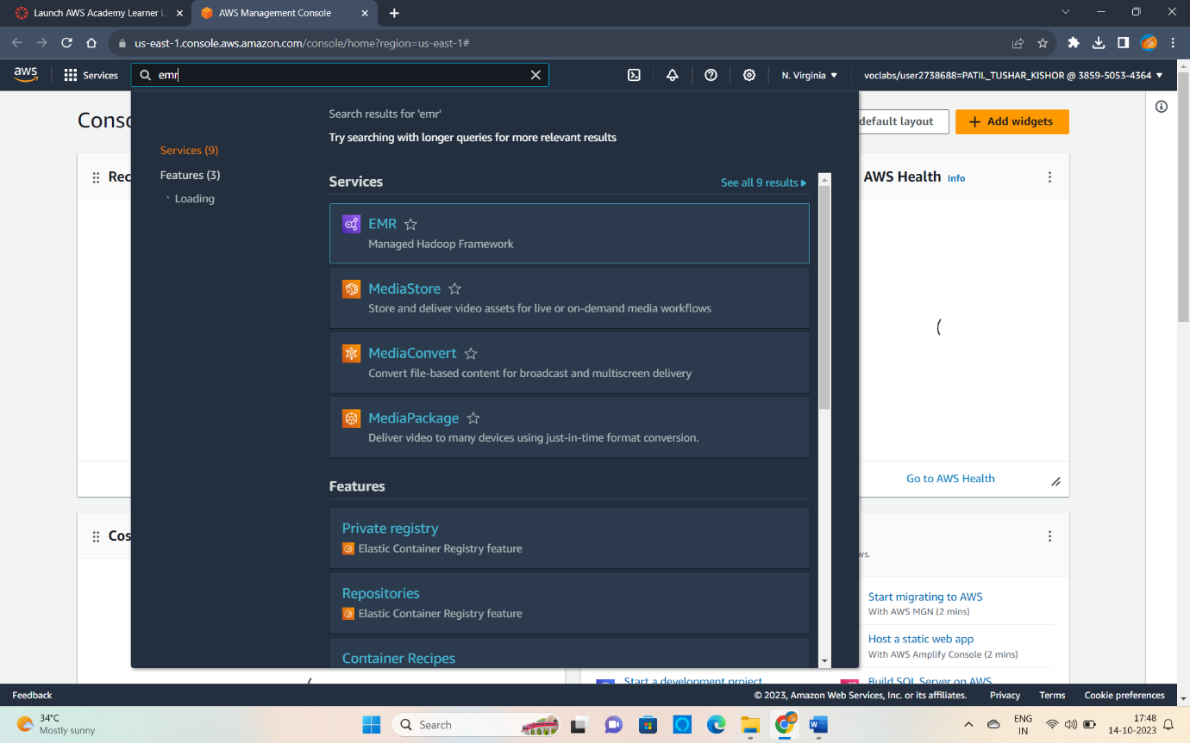

Step 2 : Click on Create cluster.

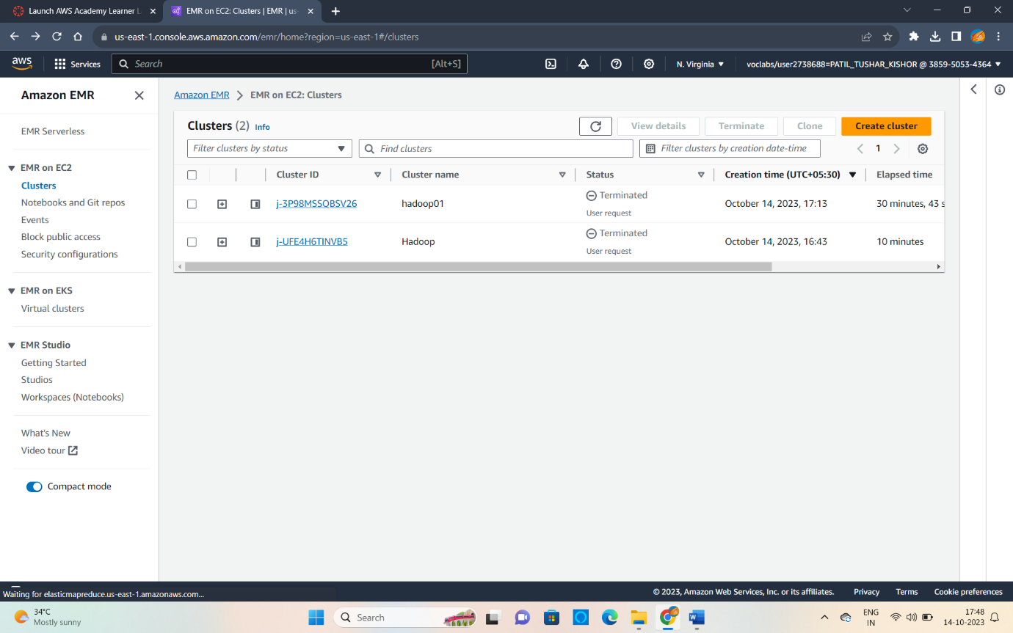

Step 3 : Give name to your cluster and choose Application bundle as Custom(aws). Keep other things as it is .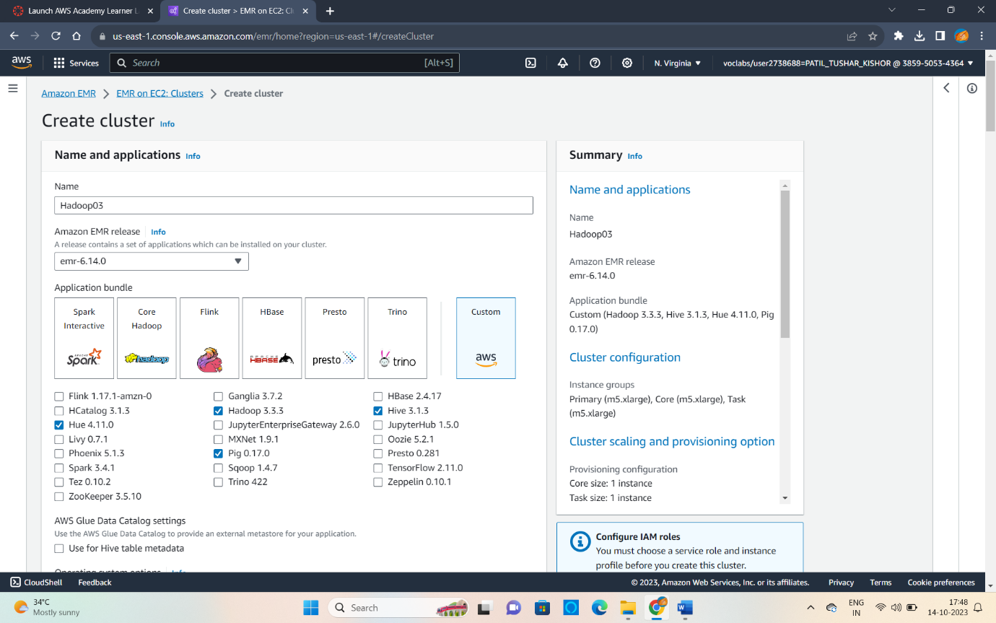

Step 4 : Uncheck the ‘Use termination protection’ option which is by default checked .

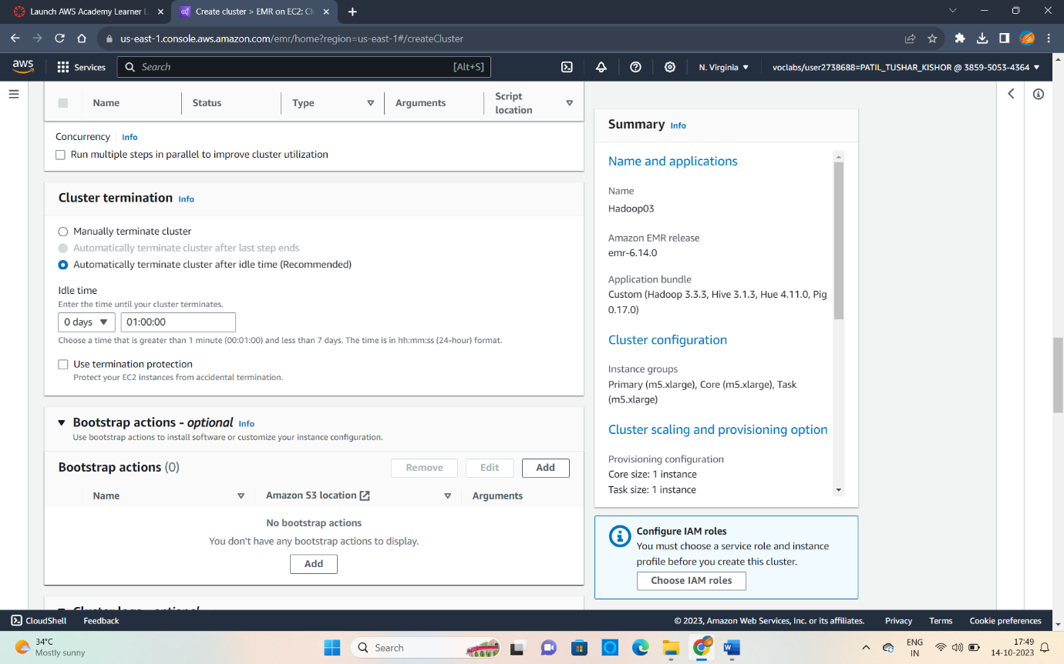

Step 5 : In Security Configuration Click on Create key pair .

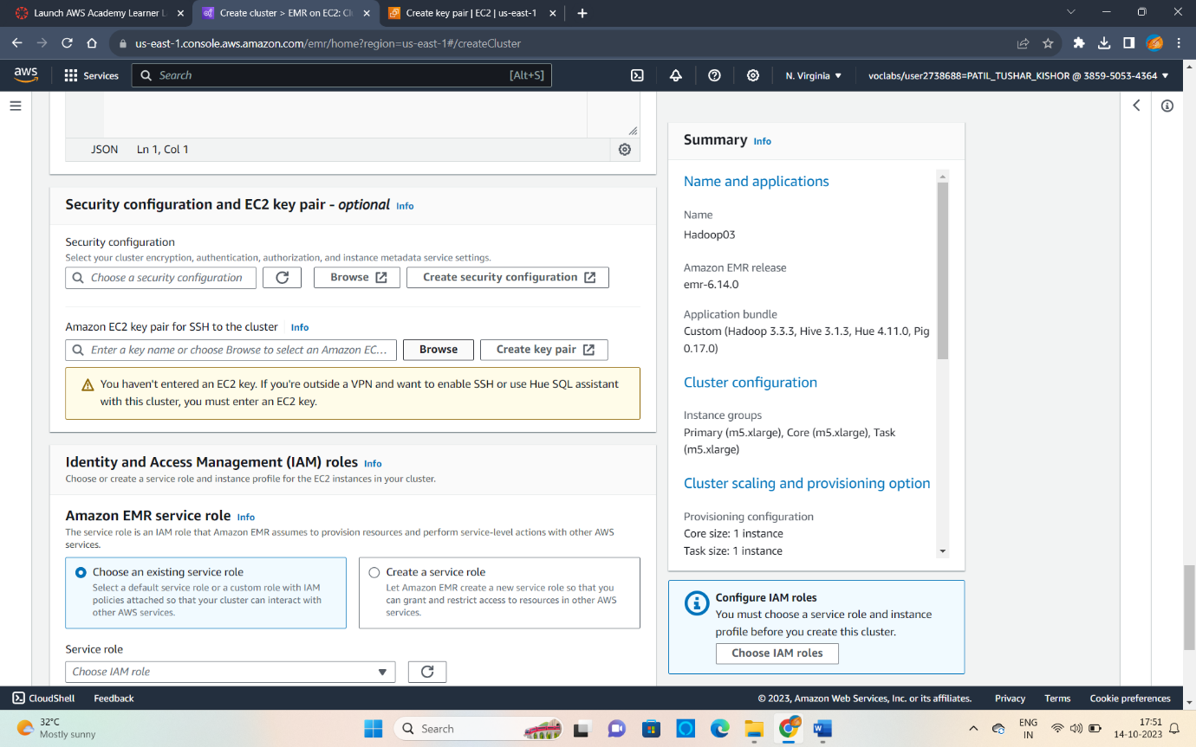

Step 6 : Give name to Key Pair and Select .pem format .

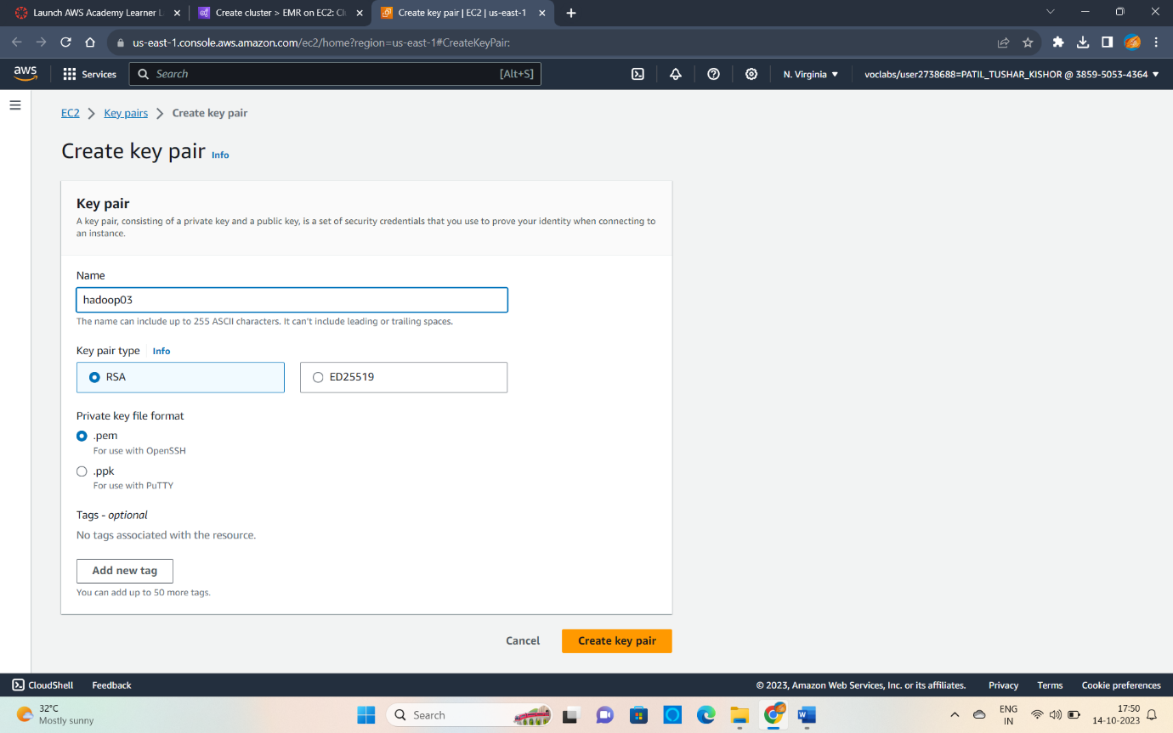

Step 7 : This page may redirect in this case select created

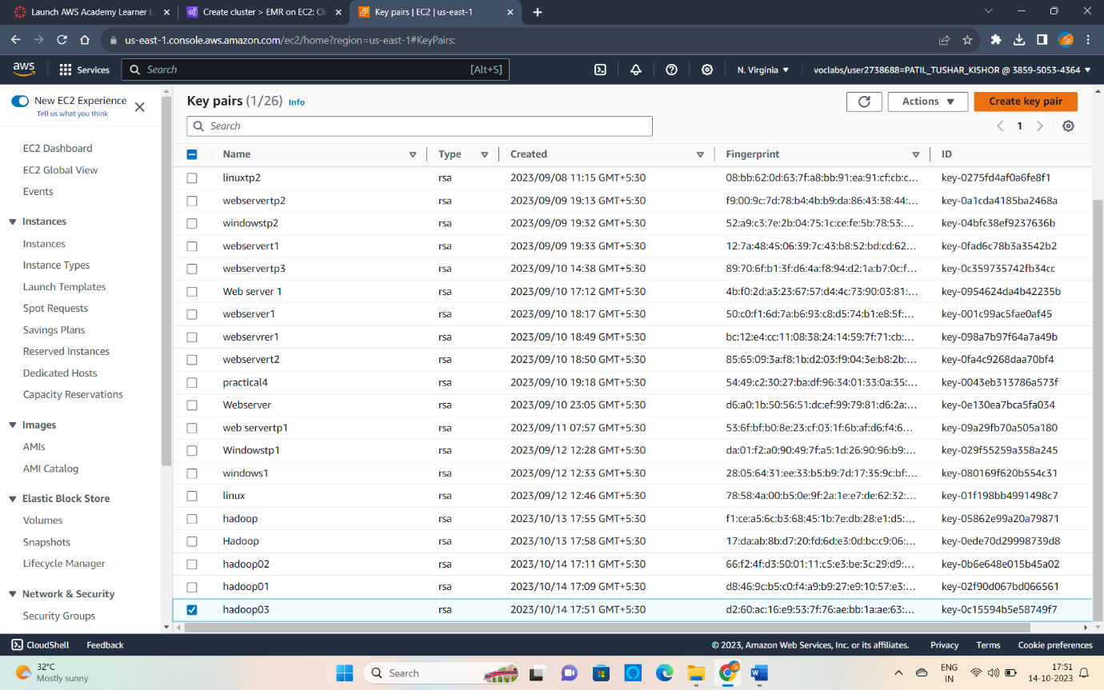

Step 8 : In Security Configuration Click on Browse and Select Key Pair.

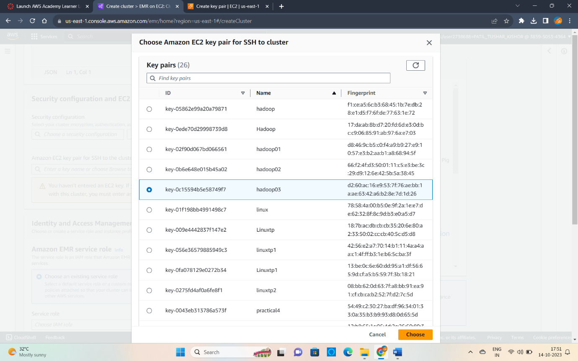

Step : Choose the Service role and Instance profile to Default Role and Click on Create Cluster.

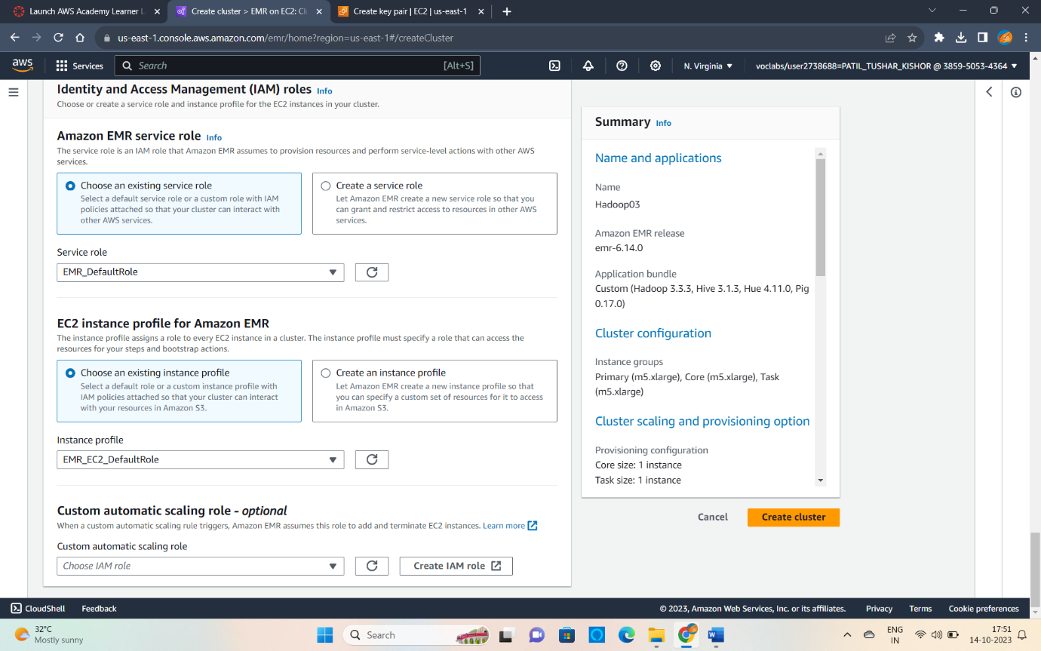

Step 11 : Now Click on the Link of Primary node .

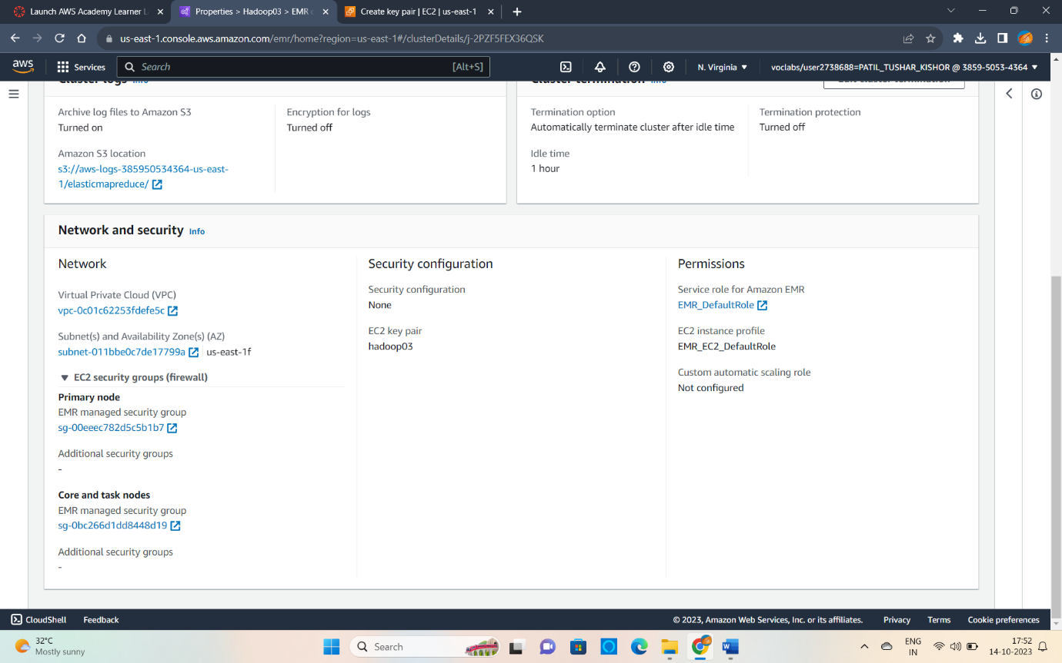

Step 12 : Click on Edit inbound rules.

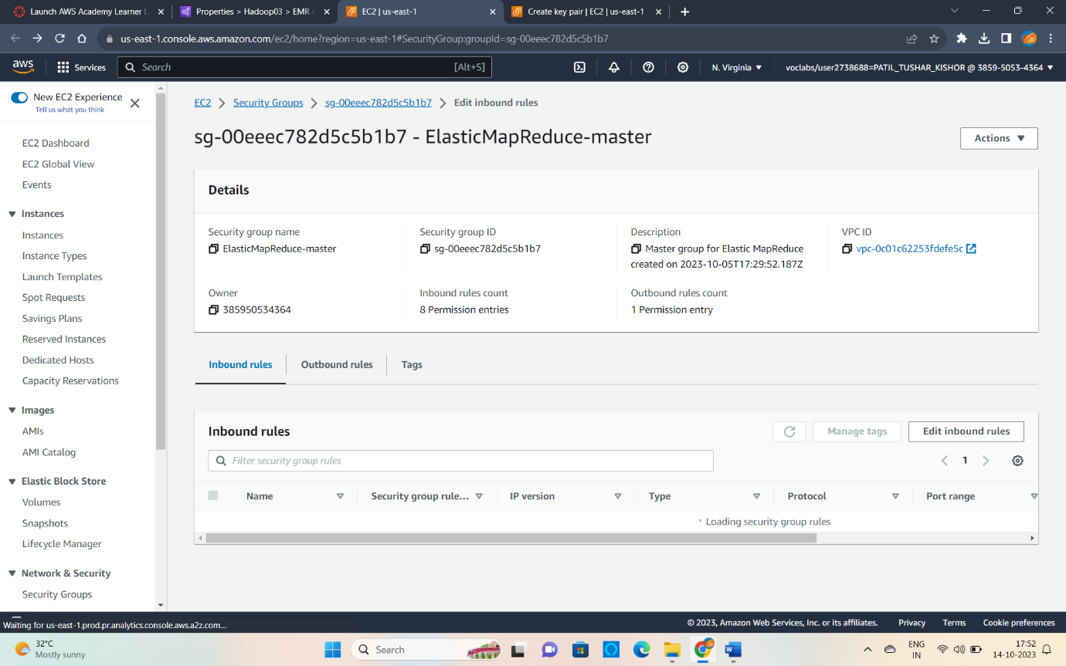

Step 13 : Click on Add rule and then Select -Type – SSH ,Source – Anywhere IPv4

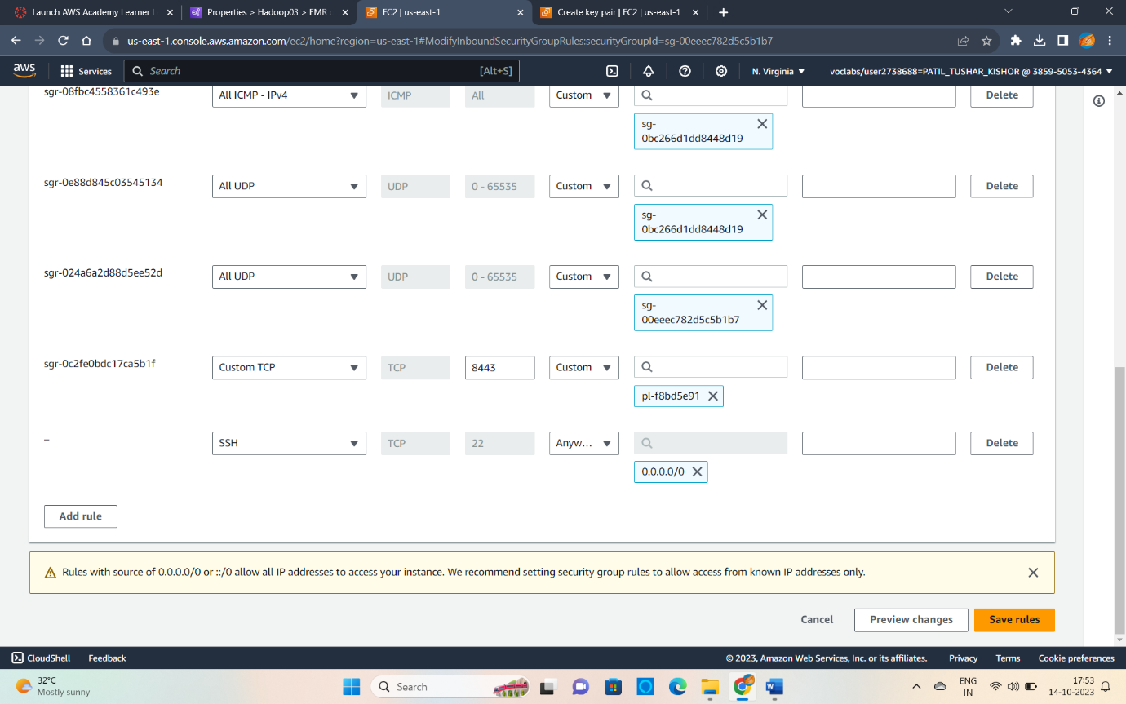

Step 14 : Open Puttygen and Click on Load and Select .pem file and Click on Save Private Key.

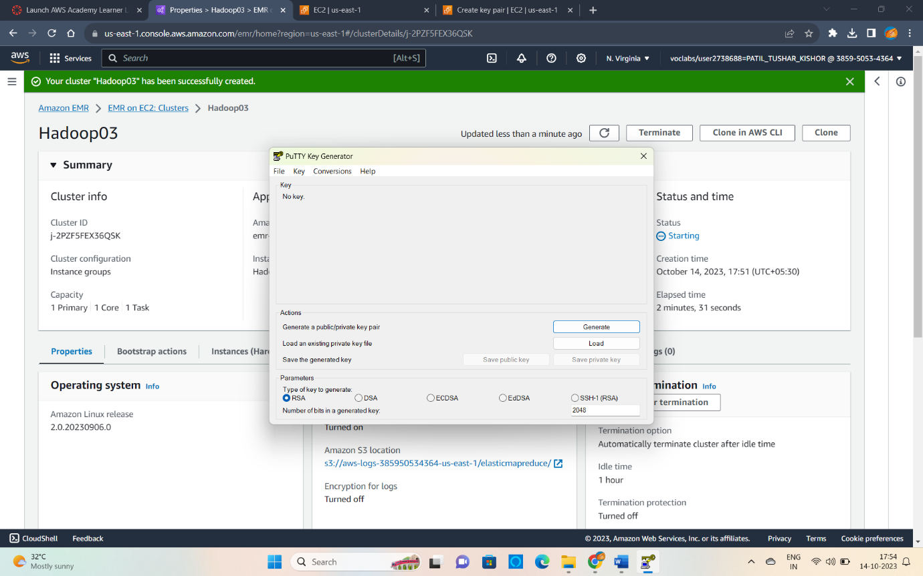

Step 15 : Copy the Primary node DNS Address.

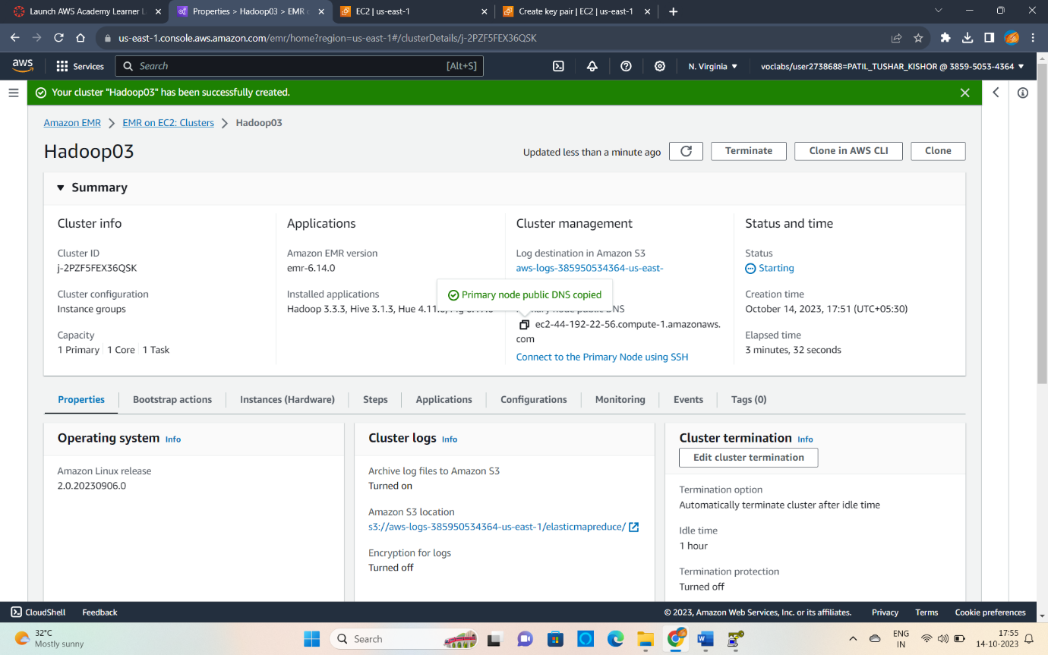

Step 16 : Paste the address in Host name then-

Connection>SSH>Auth>Credintials in this you need to open the file we have saved as .ppk.

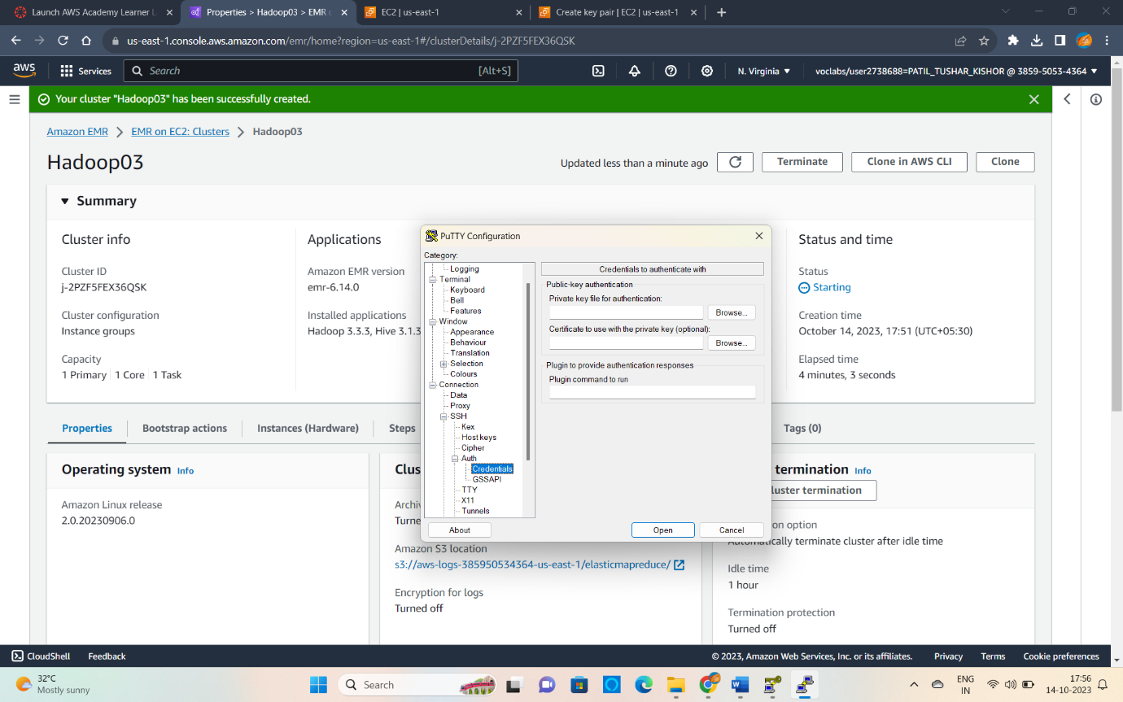

Step 17 : Click on Accept

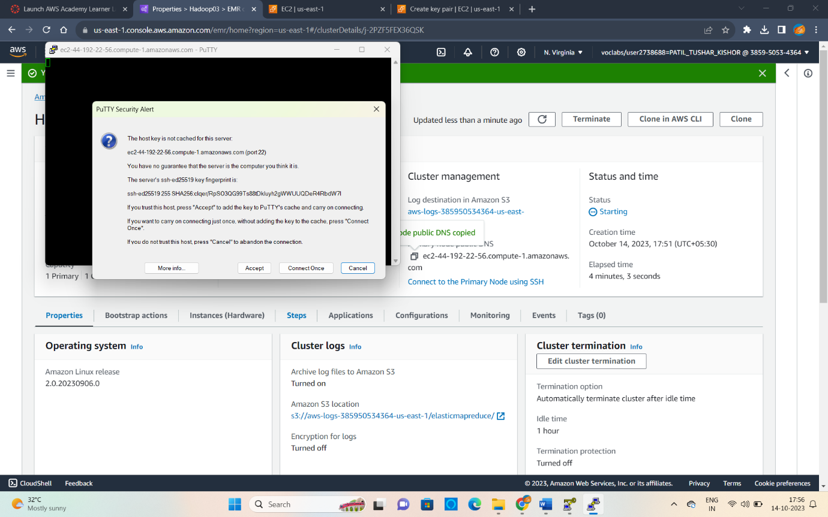

Step 18: We have successfully launched EMR Service.

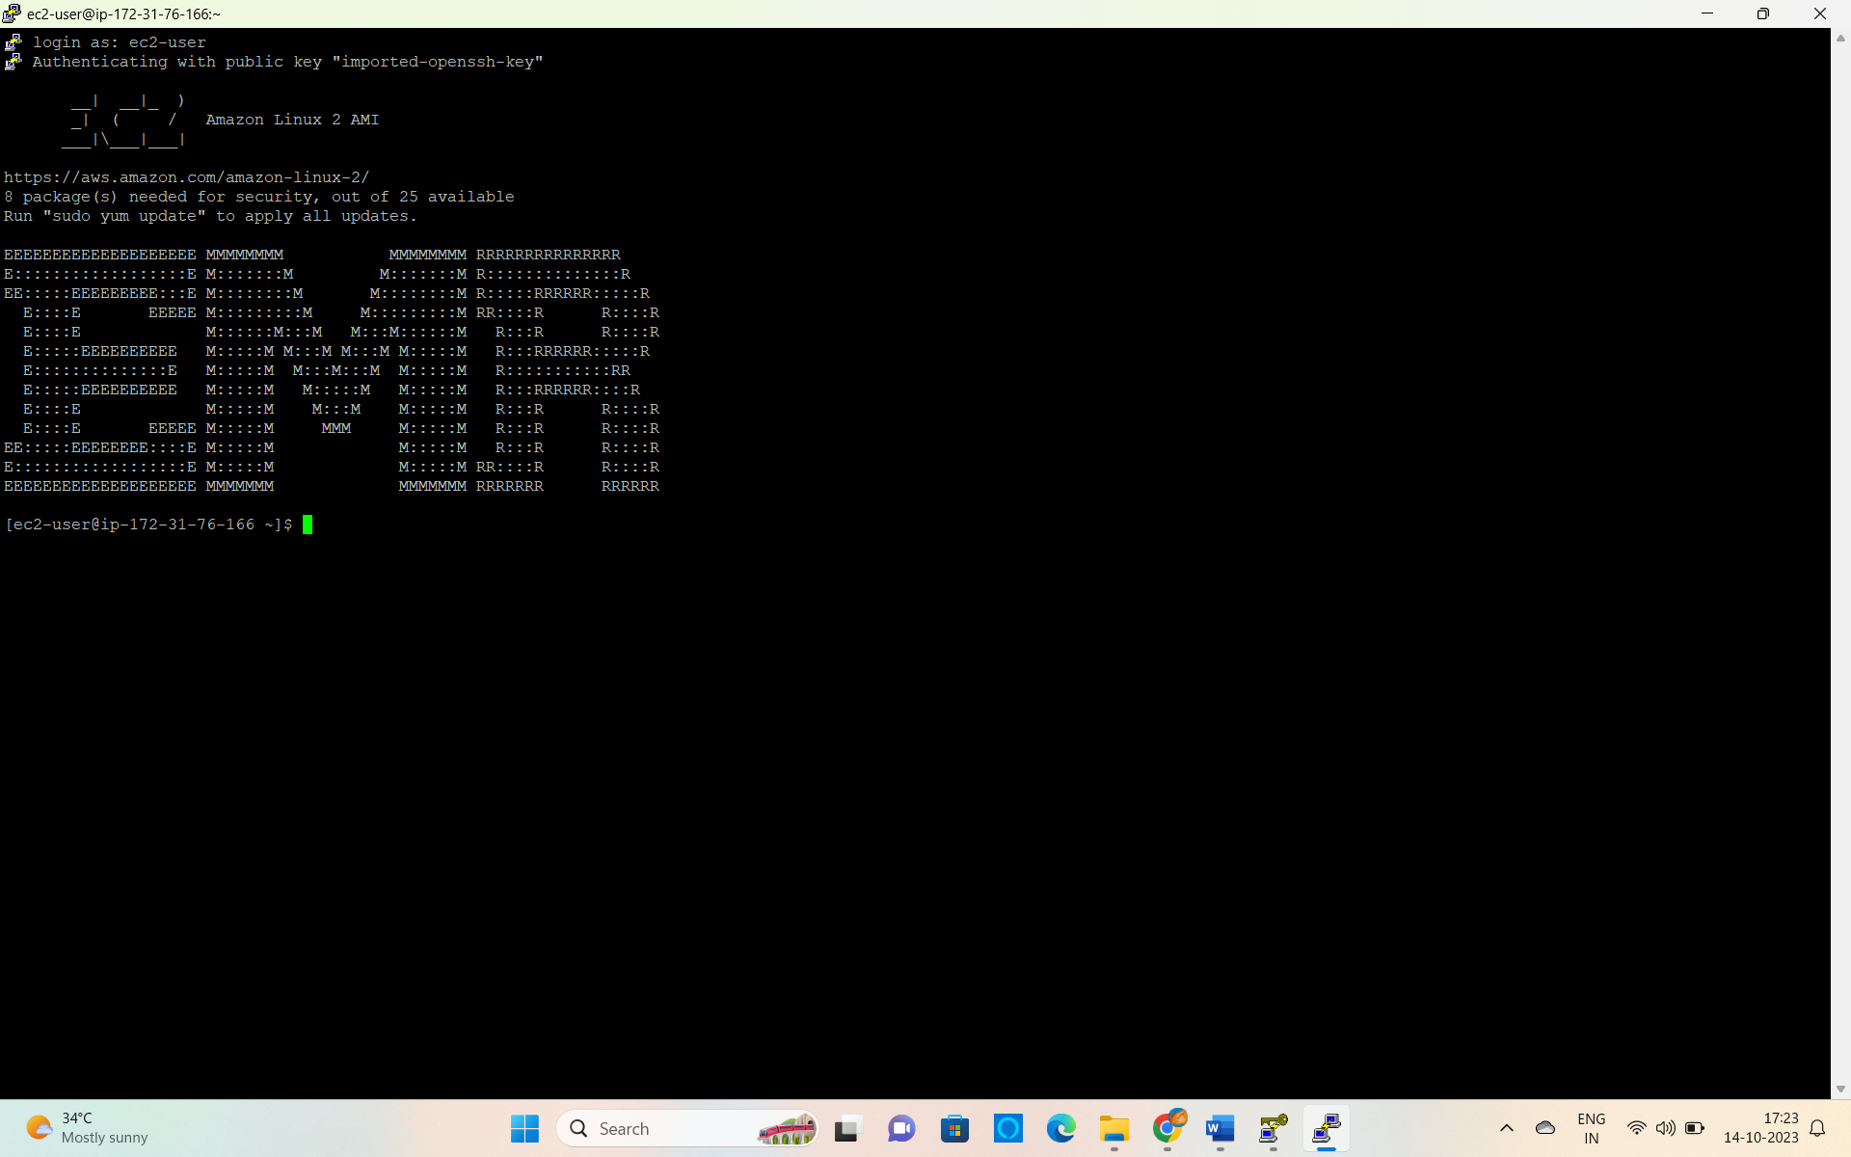

Step 19 : Now we have to run the Commands.

Sudo hive

Create database demo; ( It will create a database named demo)

Show databases; ( It will show all the databases)

Now run the command to create a table and fields.

Create table demo.employee(id int,name string, salary, string float)

Row format delimited

Fields terminated by ‘,’;

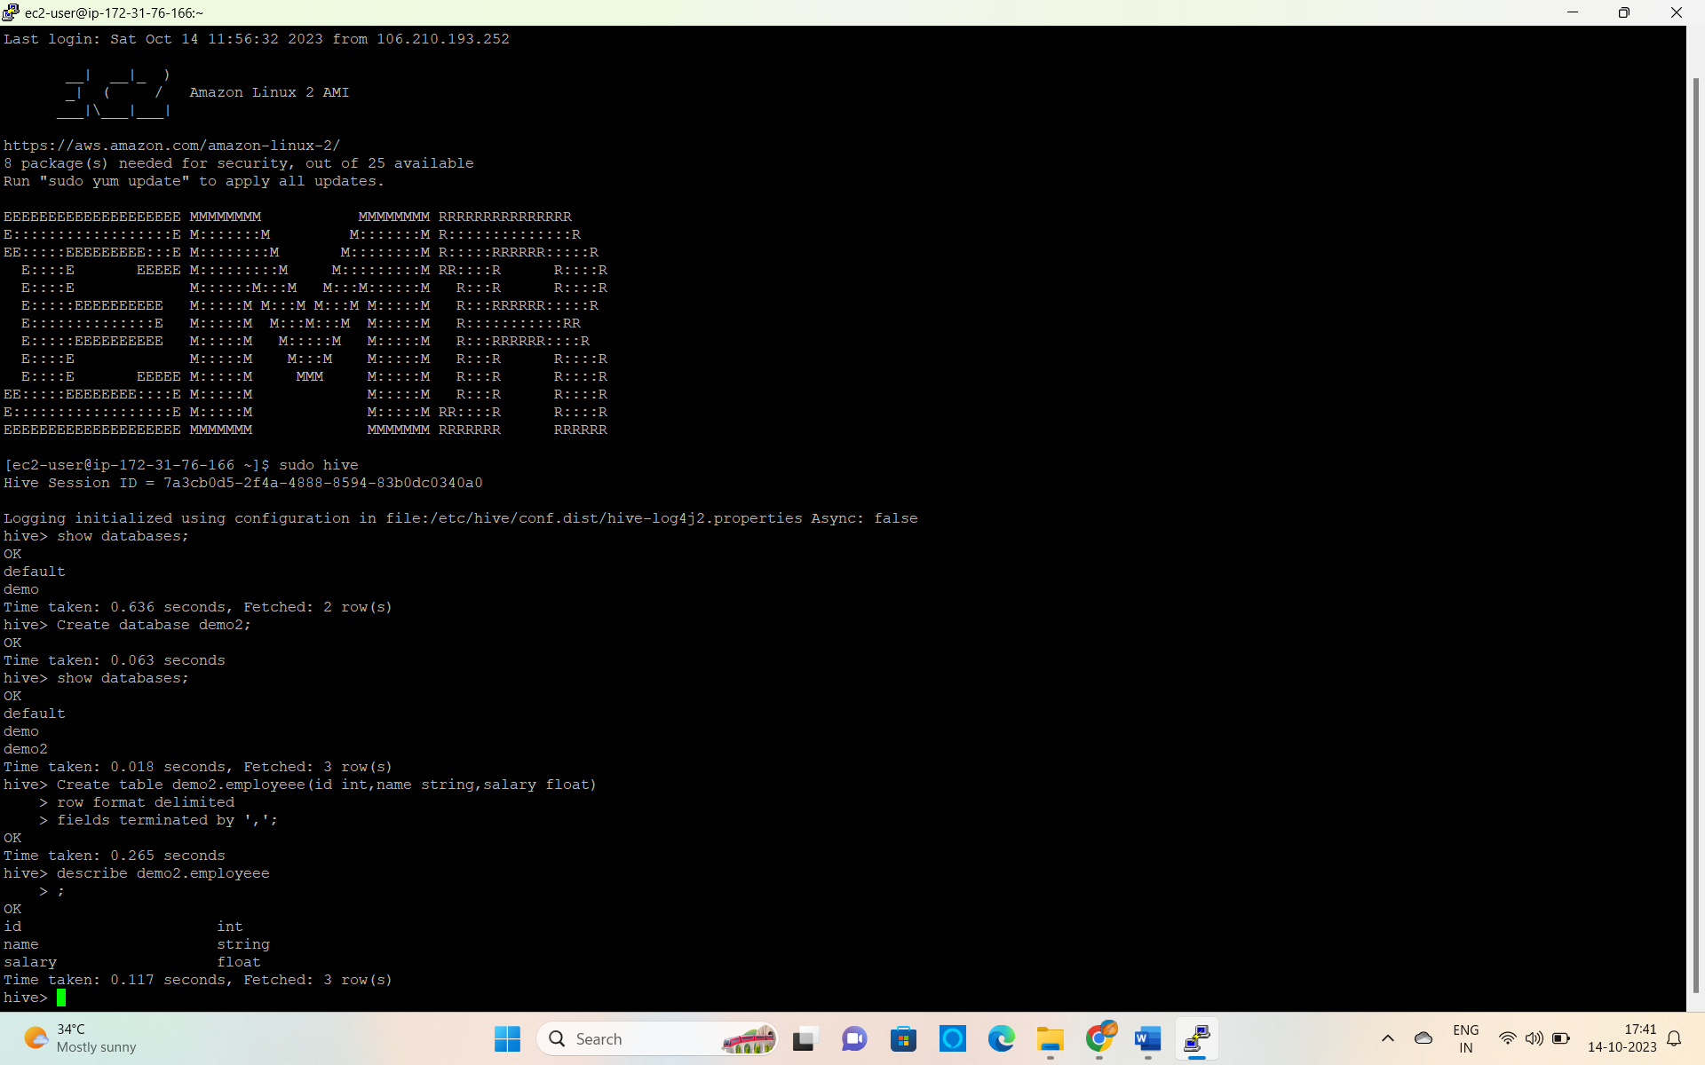

Step 20 : Click on The running Cluster and Terminate.

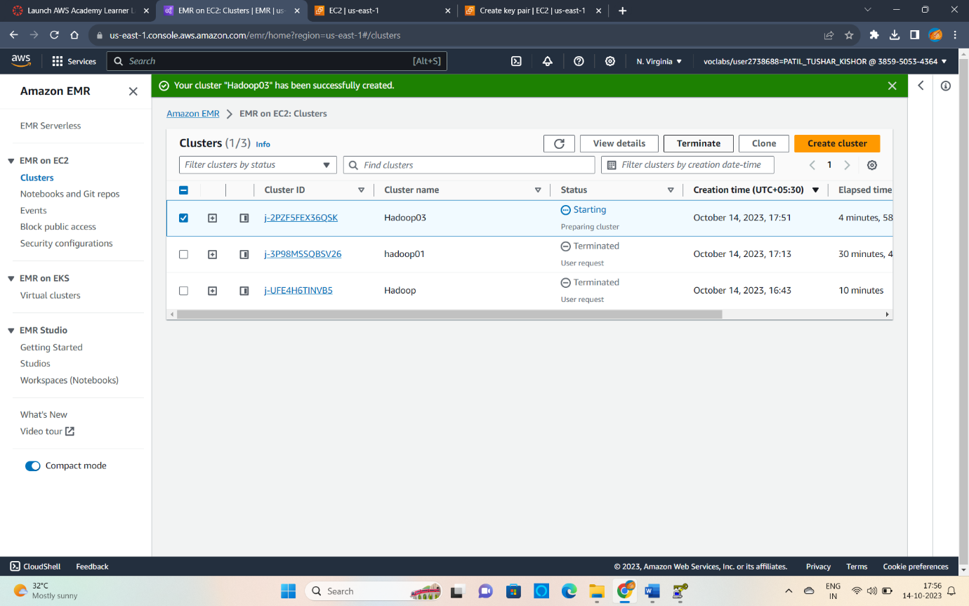

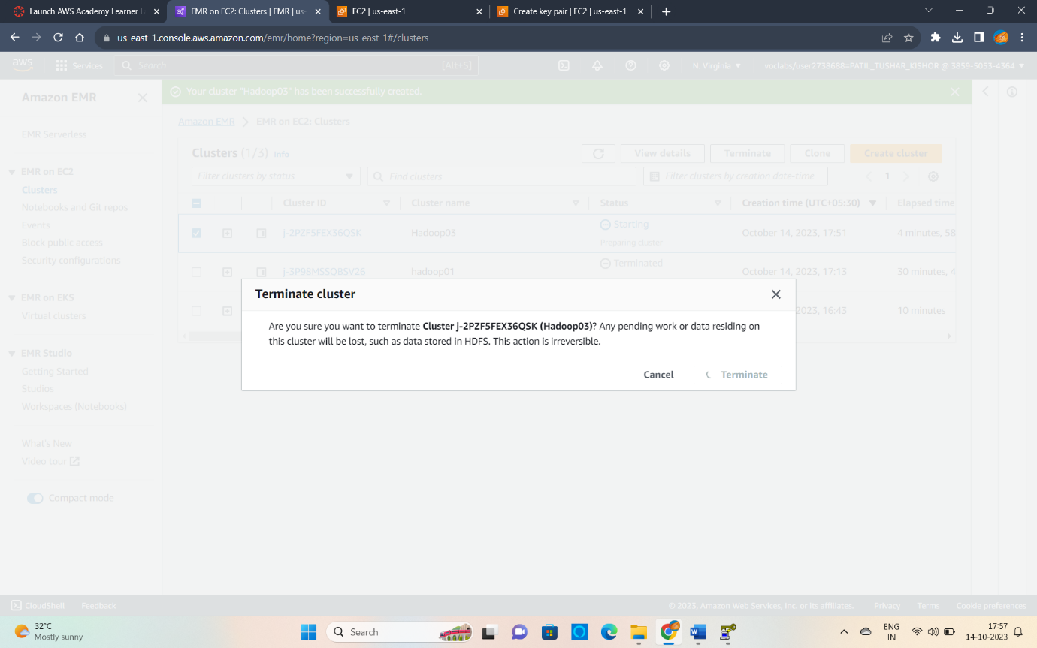

Step 21 : Sign Out of AWS Console.

